DELETING TASKS

DELETING TASKS
- In order to delete tasks, we need to add a delete_task function
- We'll know which task to delete by grabbing the user's selected task within the listbox widget

DELETE TASK FUNCTION
- listbox.curselection( ) is used to grab the user's selected task within the listbox widget and we store this in a variable
  - We edge-case our function by returning if the user doesn't selected a task
- We use a for-loop to iterate through the indices of the selected tasks and we pop them from our global tasks lists
  - To safely delete tasks, we delete them from the highest index down because deleting an index changes the order of the other indices
  - NOTE that we are not iterating through the global tasks list, we are iterating through the indices of the selected tasks within the listbox widget
- Then we call our save_tasks function

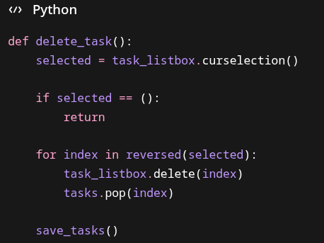

DELETE BUTTON
- Next we'll add a "Delete Task" button and pack it under the "Add Task" button and give it 5 pixels of vertical space between it and other widgets
- We must specify the command keyword argument and pass our delete_task function as the argument

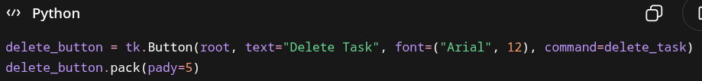

THINGS TO REMEMBER
- Because we're packing multiple objects right below one another, we may run out of space in our root-window because we specifically specified its geometry – you may have to change this

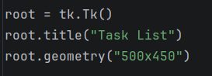

FULL CODE EXAMPLE
